Monitoring / On-Call Approval Form

Employee Name: Nikunj Adhaduk _

Manager Name: Yaser Shadmehr
.
Monitoring Hours
Date of Monitoring (mm/dd/yyyy) | Project | Reason | Number of Hours
TOTAL

On-Call Payment
Dates On-Call (mm/dd/yyyy – mm/dd/yyyy) | # of Weeks | Rate
7/6/2025 – 7/12/2025 | 1 | 200
7/13/2025 – 7/19/2025 | 1 | 200
7/20/2025 – 7/26/2025 | 1 | 200
TOTAL |  | 600
Approvals
Employee Signature: 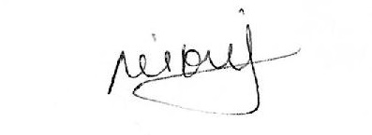 | Date:  July 25, 2025
Manager Signature: | Date:  July 25, 2025

Please submit to Payroll once approved.

Description
Date of Monitoring | Hours | Reason
July 9, 2025 | 2.5 | PROD Deployment for B2C secret rotation in Azure
July 18, 2025 | 1.5 | Prod hotfix deployment to fix the gift card issue
July 22, 2025 | 5 | Production data correction due to giftcard issue and had to be done at night after stopping the main service

